

THE UNIVERSITY OF AZAD JAMMU AND KASHMIR, MUZAFFARABAD
Department of Software Engineering

Submitted to: | Engr. Sidra Rafique
Course Title: | Data Structure and Algorithm
Course Code: | CS-2101
Session: | 2024-2028
Lab No: | 04
Roll No: | 2024-SE-15
Submitted By: | Shahzad Ahmed Awan
Submission date: | November 1, 2025
Table of Contents
Lab 04 – Doubly Linked List Implementation 3
1. Objective 3
2. Background 3
3. Algorithm 3
4. Source Code Explanation 3
4.2 Insert at End 4
4.3 Delete from Beginning 4
4.4 Delete from End 4
4.5 Display Forward and Backward 5
4.6 Menu Loop 6
5. Output 6
6. Conclusion 7
7. Reflection 7

Table of Figures
Figure 1: Code for inserting a node at the beginning of the doubly linked list. 3
Figure 2: Code for inserting a node at the end of the doubly linked list. 4
Figure 3: Code for deleting a node from the beginning of the list. 4
Figure 4: Code for deleting a node from the end of the list. 5
Figure 6: Code for displaying the list in backward directions. 5
Figure 5: Code for displaying the list in the forward directions. 5
Figure 7: Stimulation using main function 6
Figure 9: Output showing list forward 7
Figure 8: Output Showing list backward 7

Lab 04 – Doubly Linked List Implementation

1. Objective
To implement a Doubly Linked List (DLL) in C++ that performs insertion and deletion at both ends and displays data in forward and backward directions using a simple menu-driven interface.

2. Background
A Doubly Linked List consists of nodes linked in both directions using prev and next pointers.
It allows easy traversal and modification from either end, making operations efficient compared to a singly linked list.

3. Algorithm
- Start the program.
- Define a Node structure with data, prev, and next pointers.
- Create a DoublyLinkedList class with head and tail pointers.
- Implement:
  - insertAtBeginning() – adds a node at the start.
  - insertAtEnd() – adds a node at the end.
  - deleteFromBeginning() – removes the first node.
  - deleteFromEnd() – removes the last node.
  - displayForward() – shows list from head to tail.
  - displayBackward() – shows list from tail to head.
- In main(), use a loop-based menu for repeated operations.
- Clear and update the screen after each operation for clarity.
- Stop on exit.

4. Source Code Explanation

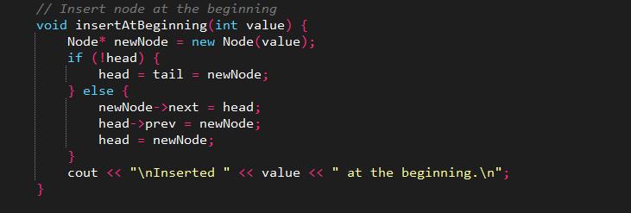
4.1 Insert at Beginning
Figure 1: Code for inserting a node at the beginning of the doubly linked list.
Creates a new node and links it before the current head.
If the list is empty, both head and tail point to the new node.

4.2 Insert at End
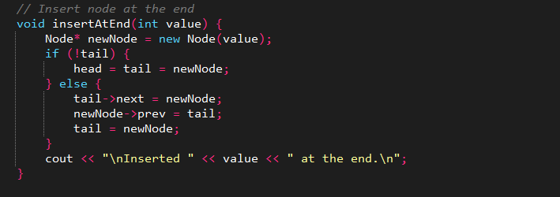
Adds a new node after the tail.
Updates the previous and next pointers to maintain proper linkage.
Figure 2: Code for inserting a node at the end of the doubly linked list.

4.3 Delete from Beginning
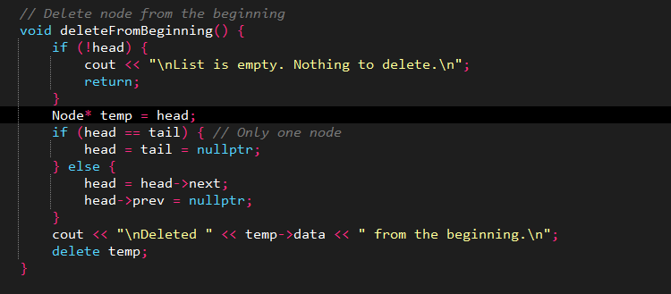
Removes the first node and reassigns head.
If only one node exists, both pointers become NULL.
Figure 3: Code for deleting a node from the beginning of the list.

4.4 Delete from End
Deletes the last node and updates the tail pointer.
Handles empty-list conditions safely.
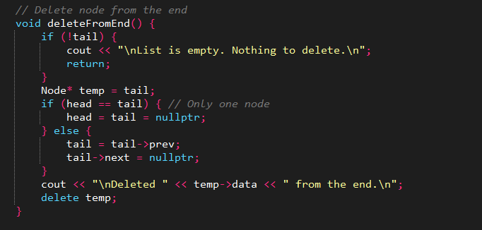
Figure 4: Code for deleting a node from the end of the list.

4.5 Display Forward and Backward
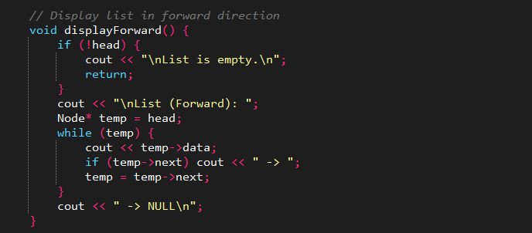
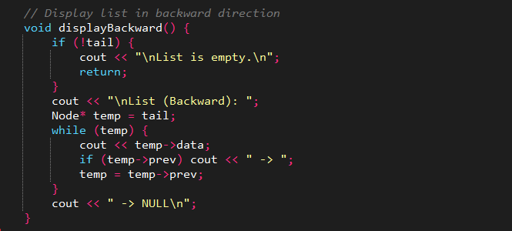
Forward display prints nodes like 9 -> 6 -> 3 -> NULL.
Backward display shows them in reverse order using prev pointers.
Figure 5: Code for displaying the list in backward directions.
Figure 6: Code for displaying the list in the forward directions.

4.6 Menu Loop
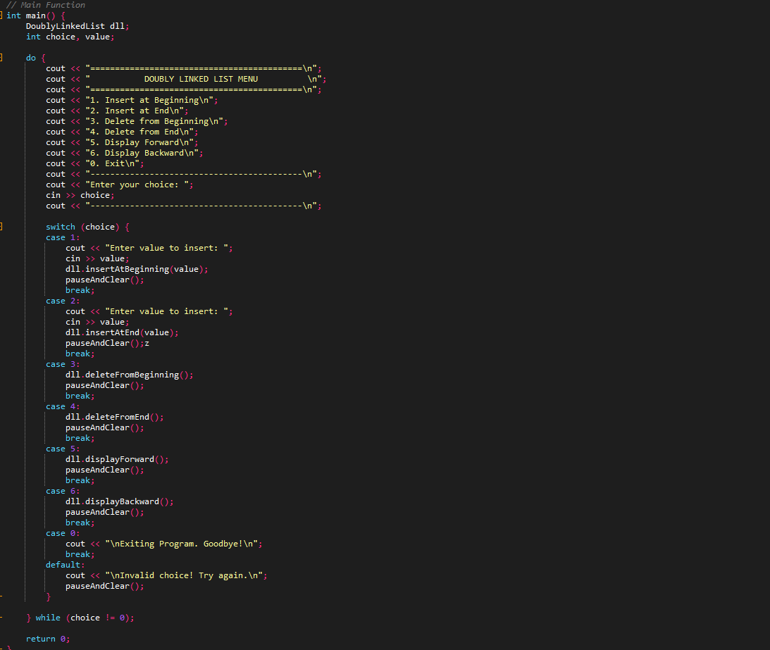
The main program runs inside a loop allowing multiple operations.
After each action, the screen refreshes, giving a clean and user-friendly display.
Figure 7: Stimulation using main function

5. Output
The program provides a menu where users can insert, delete, or display nodes.
Each operation produces clear, bordered output and updates dynamically after every action.

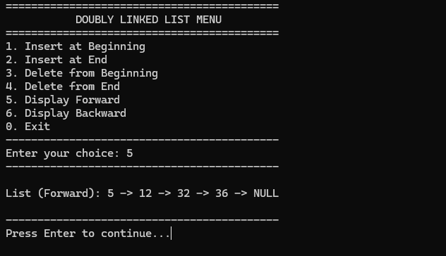
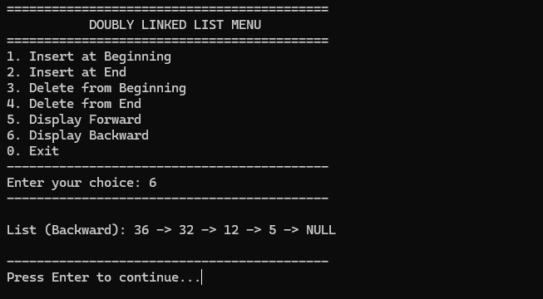
Figure 9: Output showing list forward
Figure 8: Output Showing list backward

6. Conclusion
The lab successfully implements a Doubly Linked List with insertion, deletion, and bidirectional traversal.
It demonstrates pointer manipulation and dynamic data handling in C++ effectively.

7. Reflection
This lab improved understanding of linked list operations, pointer logic, and loop-based interaction in C++.
It also showed how simple formatting enhances program readability and usability.

